Please write clearly, in BLOCK CAPITALS and black ink

Centre number Candidate number

Forename(s)

Surname

Date of Exam Time allowed: 1 hour 45 minutes

GCSE Computer Science

Paper 2: Computing concepts

Total Marks

PAPER 2B

Instructions

* Write in black ink or black ball-point pen. Use pencil only for drawing.
* Write your answer to each question in the space provided
* Answer all questions
* Do all rough work in this book
* Cross through any work you do not want marked
* **You are not allowed to use a calculator**

Information

* The total mark for this paper is **90**
* The student version of this paper has **18** pages

**Advice**

* For multiple-choice questions, completely fill in the lozenge next to the answer you want to select.



* Icon

  Description automatically generatedTo change your answer, cross out your original answer like this: Icon

  Description automatically generated
* If you want to go back to an answer you previously crossed out, circle the answer you now want to select like this:

**Answer ALL questions.**

|  |  |  |  |
| --- | --- | --- | --- |
| **0** | **1** |  |  |

A bit pattern is shown in **Figure 1**.

**Figure 1**

01110010

|  |  |  |  |
| --- | --- | --- | --- |
| **0** | **1** | **.** | **1** |

Convert the bit pattern shown in **Figure 1** into decimal.

[1 mark]

|  |  |  |  |
| --- | --- | --- | --- |
| **0** | **1** | **.** | **2** |

State the result, in binary, of applying a single left binary shift to the number in   
**Figure 1**.

[1 mark]

|  |  |  |  |
| --- | --- | --- | --- |
| **0** | **1** | **.** | **3** |

State the effect of applying a single left shift to a binary number.

[1 mark]

|  |  |  |  |
| --- | --- | --- | --- |
| **0** | **1** | **.** | **4** |

Shade **one** lozenge to indicate the amount of storage required to store the bit pattern in **Figure 1**.

[1 mark]

|  |  |  |
| --- | --- | --- |
| **A** | one bit |  |
| **B** | one byte |  |
| **C** | one kilobyte |  |
| **D** | one megabyte |  |

|  |  |  |  |
| --- | --- | --- | --- |
| **0** | **1** | **.** | **5** |

Shade **one** lozenge to indicate which of the following binary is used to represent.

[1 mark]

|  |  |  |
| --- | --- | --- |
| **A** | data |  |
| **B** | instructions |  |
| **C** | both data and instructions |  |
| **D** | neither data nor instructions |  |

|  |  |  |  |
| --- | --- | --- | --- |
| **0** | **1** | **.** | **6** |

Calculate the result of adding the following three binary numbers.

1 1 0 0 1 0 +  
1 0 0 1 0 0 0 1 +  
 1 0 0 0 1 0

[2 marks]

|  |  |  |  |
| --- | --- | --- | --- |
| **0** | **1** | **.** | **7** |

The ASCII code for ‘C’ is represented by the number 67.

Give the ASCII code numbers that represent the word CAB.

[1 mark]

|  |  |  |  |
| --- | --- | --- | --- |
| **0** | **1** | **.** | **8** |

Mobile phone text (SMS) messages may contain emoji characters such as a grinning face.

Explain why these are encoded using Unicode rather than ASCII.

[2 marks]

|  |  |  |  |
| --- | --- | --- | --- |
| **0** | **2** |  |  |

A podcaster records interviews to solid state storage on a portable recorder for their podcast.

|  |  |  |  |
| --- | --- | --- | --- |
| **0** | **2** | **.** | **1** |

Explain why the recording needs to be converted to a digital form before it can be stored on the recorder.

[2 marks]

|  |  |  |  |
| --- | --- | --- | --- |
| **0** | **2** | **.** | **2** |

The portable recorder allows the sampling rate to be changed from 44 kilohertz (44 kHz) to 50 kHz.

State the effect of changing the sampling rate on both the sound quality and the size of the file created for each recording.

[2 marks]

|  |  |  |  |
| --- | --- | --- | --- |
| **0** | **2** | **.** | **3** |

The portable recorder settings are set to the following for recording:

Sample resolution: 20 bits

Sampling rate: 50 kHz

A short 80 second interview clip is recorded for the podcast.

Calculate the file size of the interview recording. Your answer should be given in megabytes.

You should show your working.

[5 marks]

|  |  |  |  |
| --- | --- | --- | --- |
| **0** | **3** |  |  |

One method of data compression is Huffman coding. Each character in the text to be compressed is placed into a tree. The position of a character in the tree is based on how often the letter is used in the text.

A Huffman tree for the text HENRY HAS A HOUSE HERE is shown in **Figure 2**.

**Figure 2**

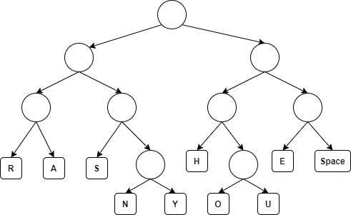

The letter U will be represented by the bit pattern 1011. This is because, from the top of the tree, U is located to the right, then left, then right, then right.

|  |  |  |  |
| --- | --- | --- | --- |
| **0** | **3** | **.** | **1** |

Using the Huffman tree in Figure 2, complete the table to show the Huffman code for the characters A, Y and Space.

[3 marks]

|  |  |
| --- | --- |
| **Character** | **Huffman code** |
| A |  |
| Y |  |
| Space |  |

|  |  |  |  |
| --- | --- | --- | --- |
| **0** | **3** | **.** | **2** |

State the word that is encoded using the tree in **Figure 2** and the following Huffman code:

0000010110

[2 marks]

|  |  |  |  |
| --- | --- | --- | --- |
| **0** | **3** | **.** | **3** |

The text A HEN requires 16 bits when using Huffman coding and the Huffman tree in **Figure 2**.

Calculate the number of bits that are saved by compressing the text A HEN using the Huffman tree in **Figure 2** rather than uncompressed ASCII. Show your working.

[3 marks]

|  |  |  |  |
| --- | --- | --- | --- |
| **0** | **4** | **.** | **1** |

Complete the truth table for the OR logic gate.

[1 mark]

|  |  |  |
| --- | --- | --- |
| **A** | **B** | **A OR B** |
| 0 | 0 |  |
| 0 | 1 |  |
| 1 | 0 |  |
| 1 | 1 |  |

A Boolean expression is given for a circuit in **Figure 3**.

**Figure 3**

$$P=\left(A+B\right).\overline{C}$$

|  |  |  |  |
| --- | --- | --- | --- |
| **0** | **4** | **.** | **2** |

Complete the truth table for three combinations of input for the expression in **Figure 3**.

[3 marks]

|  |  |  |  |
| --- | --- | --- | --- |
| A | B | C | P |
| 0 | 0 | 0 |  |
| 0 | 0 | 1 |  |
| 0 | 1 | 0 |  |

|  |  |  |  |
| --- | --- | --- | --- |
| **0** | **4** | **.** | **3** |

Complete the logic circuit for the Boolean expression given in **Figure 3**.

[3 marks]

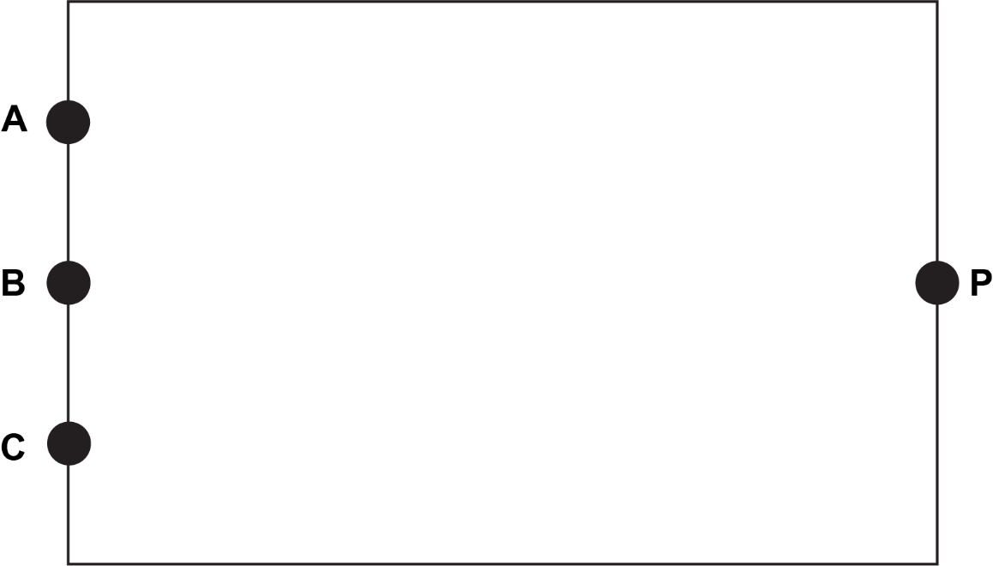

|  |  |  |  |
| --- | --- | --- | --- |
| **0** | **5** |  |  |

In recent years, there has been an increase in the number of people using wearable technologies, such as smart watches.

Discuss the advantages and disadvantages of wearable technologies.

In your answer you should include an explanation of the reasons for the increase in recent years and consider any legal, ethical and environmental issues related to the use of wearable technologies.

[9 marks]

|  |  |  |  |
| --- | --- | --- | --- |
| **0** | **6** |  |  |

**Figure 4** shows an example of some assembly code.

MOV R0, #7  
 MOV R1, #15  
 JMP calc  
back:  
 MOV #16, R2

calc:  
 SUB R2, R1, R0  
 JMP back

**Figure 4**

|  |  |  |  |
| --- | --- | --- | --- |
| **0** | **6** | **.** | **1** |

Shade **one** lozenge to indicate what action is needed before the program can be run.

[1 mark]

|  |  |  |
| --- | --- | --- |
| **A** | An assembler needs to translate the assembly code into machine code. |  |
| **B** | The assembly code is a low-level language, so can be directly run. |  |
| **C** | The assembly code must first be compiled before it can be run. |  |
| **D** | All the above are correct. |  |

|  |  |  |  |
| --- | --- | --- | --- |
| **0** | **6** | **.** | **2** |

A company has a program that is currently saved as machine code.

When the company sells the software, they tell customers that they will need a specific type of CPU for the software to work.

Give **one** reason why it won’t work with a different type of CPU.

[1 mark]

|  |  |  |  |
| --- | --- | --- | --- |
| **0** | **6** | **.** | **3** |

A programmer has made a program using the high-level language Python. Python is an example of an interpreted language.

Explain **one** disadvantage of using an interpreted language rather than a compiled language.

[2 marks]

|  |  |  |  |
| --- | --- | --- | --- |
| **0** | **7** | **.** | **1** |

Both RAM and ROM are types of main memory.

Shade **one** lozenge to indicate the features of RAM and ROM.

[1 mark]

|  |  |  |
| --- | --- | --- |
| **A** | Both RAM and ROM are volatile |  |
| **B** | RAM is non-volatile and ROM is volatile |  |
| **C** | RAM is volatile and ROM is non-volatile |  |
| **D** | Both RAM and ROM are non-volatile |  |

|  |  |  |  |
| --- | --- | --- | --- |
| **0** | **7** | **.** | **2** |

One type of physical storage is optical storage. Give **one** other type of physical storage.

[1 mark]

|  |  |  |  |
| --- | --- | --- | --- |
| **0** | **7** | **.** | **3** |

Describe the operation of optical storage.

[3 marks]

|  |  |  |  |
| --- | --- | --- | --- |
| **0** | **7** | **.** | **4** |

Explain the role of registers in a central processing unit (CPU).

[2 marks]

|  |  |  |  |
| --- | --- | --- | --- |
| **0** | **7** | **.** | **5** |

Explain the effect of increasing cache size on the performance of a CPU.

[2 marks]

|  |  |  |  |
| --- | --- | --- | --- |
| **0** | **7** | **.** | **6** |

A portable music player makes use of solid state storage. Explain **one** advantage of using solid state rather than optical storage.

[2 marks]

The portable music player is an example of an embedded system.

|  |  |  |  |
| --- | --- | --- | --- |
| **0** | **7** | **.** | **7** |

Give **two** other examples of embedded systems.

[2 marks]

|  |  |  |  |
| --- | --- | --- | --- |
| **0** | **7** | **.** | **8** |

Explain how an embedded system differs from a non-embedded system.

[2 marks]

|  |  |  |  |
| --- | --- | --- | --- |
| **0** | **8** | **.** | **1** |

The Internet is a well-known example of a computer network.

Shade **one** lozenge to indicate the type of network which the Internet forms.

[1 mark]

|  |  |  |
| --- | --- | --- |
| **A** | LAN |  |
| **B** | PAN |  |
| **C** | WAN |  |
| **D** | All of the above (A, B and C) |  |
| **E** | None of the above (None of A, B and C) |  |

Figure 5 shows an office’s computer network topology.

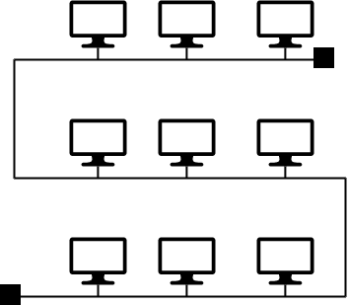

**Figure 5**

|  |  |  |  |
| --- | --- | --- | --- |
| **0** | **8** | **.** | **2** |

State the type of topology that has been used in Figure 5.

[1 mark]

|  |  |  |  |
| --- | --- | --- | --- |
| **0** | **8** | **.** | **3** |

Describe **one** disadvantage in the office using this type of network topology.

[2 marks]

|  |  |  |  |
| --- | --- | --- | --- |
| **0** | **8** | **.** | **4** |

One common network protocol is TCP. Describe what this protocol is used for.

[2 marks]

|  |  |  |  |
| --- | --- | --- | --- |
| **0** | **8** | **.** | **5** |

Different protocols operate in different network layers.

Shade **one** lozenge to indicate the network layer that both TCP and UDP operate in.

[1 mark]

|  |  |  |
| --- | --- | --- |
| **A** | Application layer |  |
| **B** | Internet layer |  |
| **C** | Link layer |  |
| **D** | Transport layer |  |

|  |  |  |  |
| --- | --- | --- | --- |
| **0** | **8** | **.** | **6** |

Give **one** protocol that operates in the Internet layer.

[1 mark]

|  |  |  |  |
| --- | --- | --- | --- |
| **0** | **9** | **.** | **1** |

Define the term cyber security.

[2 marks]

|  |  |  |  |
| --- | --- | --- | --- |
| **0** | **9** | **.** | **2** |

A company has written to all employees to tell them that they will no longer be allowed to use removable media on the company computers due to the cyber security threat.

Describe how removable media could be a cyber security threat to an organisation.

[2 marks]

|  |  |  |  |
| --- | --- | --- | --- |
| **0** | **9** | **.** | **3** |

Social engineering is the art of manipulating people, so they give up confidential information. One method of social engineering is blagging (pretexting).

State **two** other techniques used in social engineering.

**[2 marks]**

|  |  |  |  |
| --- | --- | --- | --- |
| **0** | **9** | **.** | **4** |

Describe how blagging could be used to obtain confidential information.

[2 marks]

|  |  |  |  |
| --- | --- | --- | --- |
| **1** | **0** | **.** | **1** |

Give **two** functions provided by an operating system.

[2 marks]

|  |  |  |  |
| --- | --- | --- | --- |
| **1** | **0** | **.** | **2** |

One example of utility software is a formatting utility.

Describe the purpose of **one** other type of utility software.

[3 marks]

|  |  |  |  |
| --- | --- | --- | --- |
| **1** | **1** |  |  |

A seaside town has a crazy golf course. Customers are able to download an app which allows them to record the number of putts they make for each hole. The database is stored on a server on the Internet.

The player details are stored in a table named Players.

At the end of each hole, the user uploads the number of putts they took to finish the hole (TotalPutts) along with the hole’s number (HoleNumber). A number of players can play together, in which case they will all have the same GameNumber.

The contents of the tables are shown in **Figure 6**.

**Figure 6**

**Players**

|  |  |  |  |
| --- | --- | --- | --- |
| **PlayerID** | **Firstname** | **Lastname** | **Age** |
| 1 | Chantelle | Ortega | 23 |
| 2 | Dennis | Hirst | 15 |
| 3 | Ellena | Rowe | 14 |
| 4 | Jason | McCarthy | 9 |
| 5 | Anushka | Patel | 17 |

**Putts**

|  |  |  |  |  |
| --- | --- | --- | --- | --- |
| **PlayerID** | **StrokeID** | **GameNumber** | **HoleNumber** | **TotalPutts** |
| 1 | 14 | 5 | 18 | 3 |
| 2 | 15 | 5 | 18 | 4 |
| 1 | 16 | 6 | 1 | 1 |
| 1 | 17 | 6 | 2 | 3 |
| 4 | 18 | 6 | 1 | 2 |
| 3 | 19 | 6 | 1 | 1 |
| 5 | 20 | 7 | 5 | 2 |

|  |  |  |  |
| --- | --- | --- | --- |
| **1** | **1** | **.** | **1** |

State the field in the Putts table that is a foreign key.

[1 mark]

|  |  |  |  |
| --- | --- | --- | --- |
| **1** | **1** | **.** | **2** |

Shade **one** lozenge to indicate what the data in **Figure 7** is.

**Figure 7**

*3 Ellena Rowe 14*

[1 mark]

|  |  |  |
| --- | --- | --- |
| **A** | A field |  |
| **B** | A record |  |
| **C** | A table |  |
| **D** | A primary key |  |

|  |  |  |  |
| --- | --- | --- | --- |
| **1** | **1** | **.** | **3** |

Write an SQL query that could be used to find the player’s first name, last name, game number and hole number for any holes in one (where the player took only one putt on the hole).

[5 marks]